**Spike:**  *20*

**Title:** Collision

**Author:** Steven Efthimiadis, 1627406

**Goals / deliverables:**

The goal is when an Object collides with another. Change the Materiel of it

To create this spike, you require:

* Materiel Editing
* Collisions
* Blueprints

**Technologies, Tools, and Resources used:**

List of information needed by someone trying to reproduce this work

* Materials
  + <https://docs.unrealengine.com/latest/INT/Engine/Rendering/Materials/>
* Collisions
  + <https://docs.unrealengine.com/latest/INT/Engine/Physics/Collision/>

**Tasks undertaken:**

* Add a couple of Actors (Shapes are good)
* Create a few materials
* Add to the project
* Create the blueprints

**What we found out:**

* You can either the collision to be what type you want you want if you click on the mesh in the ui.

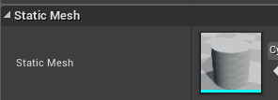 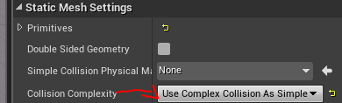

**Open issues/ risks:**

* Trying to change the material on collision was harder than expected. If you have any trouble, there are a few pictures of who you should look at it

